Title:
Source:
Problem: min
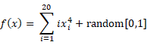

Optimal Value: 0
Optimal Solution(s):
xi = 0, i = 0,1,2,.....,n
Edited by: LIN-YU, TING
Date: 1/16/2021

